Web Tech Lab Assignment 1

9th August 2024

1. Create a webpage using HTML that prints heading titled “Welcome To VIPS

Family” at the centre of the screen with different heading size.

Source Code:

 <!-- Create a webpage using HTML that prints heading titled “Welcome To VIPS

      Family” at the centre of the screen with different heading size. -->

<!DOCTYPE html>

<html lang="en">

<head>

    <meta charset="UTF-8">

    <meta name="viewport" content="width=device-width, initial-scale=1.0">

    <title>WT Assignment 1</title>

</head>

<body>

    <h1 align="center">Welcome to VIPS Family</h1>

    <h2 align="center">Welcome to VIPS Family</h2>

    <h3 align="center">Welcome to VIPS Family</h3>

    <h4 align="center">Welcome to VIPS Family</h4>

    <h5 align="center">Welcome to VIPS Family</h5>

    <h6 align="center">Welcome to VIPS Family</h6>

</body>

</html>

Output:

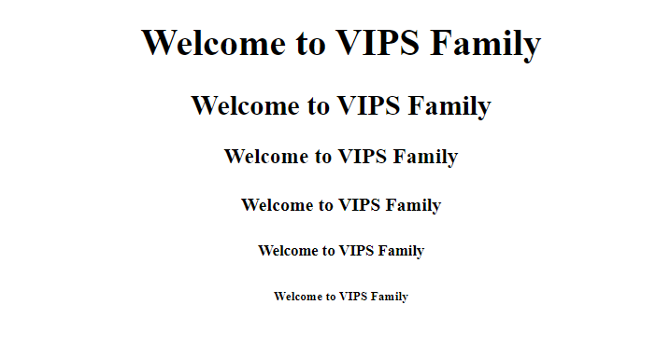

1. Create a webpage using HTML to implement Text formatting Tags such as

Bold, Italic, Underline, Strike, Marquee, Subscript, Superscript, Font as well as

the use of empty tags such as <br> <hr>.

Source Code:

<!--Create a webpage using HTML to implement Text formatting Tags such as

    Bold, Italic, Underline, Strike, Marquee, Subscript, Superscript, Font as well as

    the use of empty tags such as &lt;br&gt;, &lt;hr&gt;-->

<!DOCTYPE html>

<html lang="en">

<head>

    <meta charset="UTF-8">

    <meta name="viewport" content="width=device-width, initial-scale=1.0">

    <title>WT Assignment 1</title>

</head>

<body>

    <hr>

    <p align="center"> Creating a webpage using HTML</p>

    <p align="center"> Implementing text formatting tags such as</p>

    <p align="center"> <b>Bold</b> <br> <i>Italic</i> <br> <u>Underline</u> <br> <s>Strike</s></p>

    <p align="center"> Also a <sub>Subscript</sub> and a <sup>SuperScript</sup></p>

    <hr>

</body>

</html>

Output:

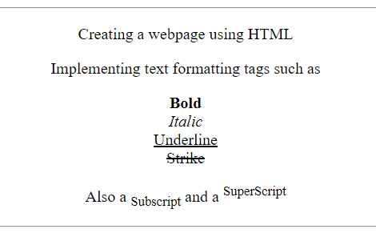

3. Create a webpage using HTML to implement different types of ordered as

well as unordered list as follows:

Source Code:

<!DOCTYPE html>

<html lang="en">

<head>

    <meta charset="UTF-8">

    <meta name="viewport" content="width=device-width, initial-scale=1.0">

    <title>WT Assignment 1</title>

</head>

<body bgcolor="pink">

    <h1 align="center"> Online Books Library</h1>

    <p>Books are our best friends. We can obatain many thoughts from books. <br>

        The Various types of books Featured in our library are: </p>

    <ol type="A" start="1">

        <li>Autobiography</li>

       <ol type="a" start="1">

            <li>My Experiments with truth</li>

            <li>Wings of Fire</li>

        </ol>

        <li>Fiction</li>

        <ul>

            <li>Bacon Death</li>

            <li>Pride and Predujice</li>

        </ul>

        <li>Adventure</li>

        <ul>

            <li>Gulliver's Travel</li>

            <li>The Phanton Toolbooth</li>

        </ul>

    </ol>

</body>

</html>

Output:

